**PROJECT**

**TITLE:**

IOT GARBAGE MONITORING SYSTEM

**OBJECTIVE:**

THE OBJECTIVE OF MY PROJECT IS TO EASILY MONITOR GARBAGE PRESENT IN THE DUSTBIN FROM ANY FAR OFF PLACES, SO THAT THERE WILL BE TIDY AND NEATNESS AROUND THE PLACES AND NEAR THE DUSTBIN.

**FEATURES:**

* IT USES AN ESP MODULES (IOT MODULE), SO IT EASY TO MONITOR FROM ANY PLACE.
* IT CAN SHOW CURRENT STATE OF UPTO 2 DUSTBINS.
* LED AND BUZZER WILL SHOW INDICATION, WHEN THE DUSTBINS ARE FULL.
* IT IS ACCURATE UPTO 95%,
* LCD DISPLAY WILL SHOW THE CURRENT STATE OF THE DUSTBIN.
* IT IS A VERY FAST AND CHEAP PRODUCT.

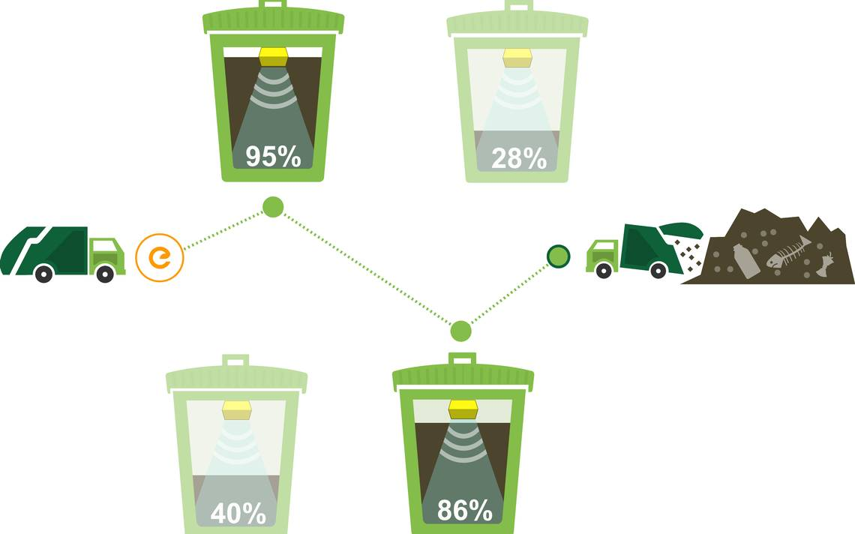

**GARBAGE MONITORING SYSTEM**

**BLOCK DIAGRAM:**

LIQUID CRYSTAL

DISPLAY

VOLTAGE

REGULATOR 1

POWER

SUPPLY 1

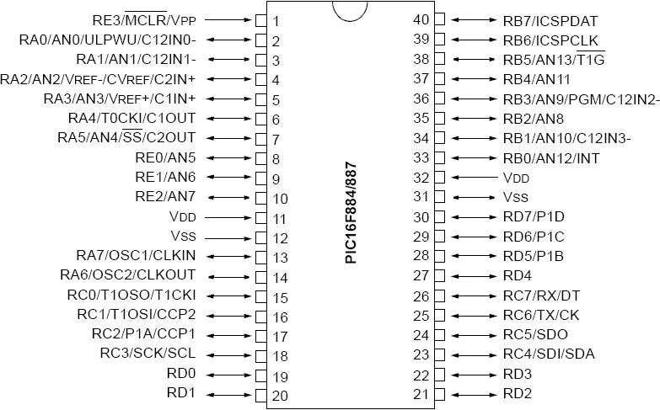

BUZZER

LED

POWER

SUPPLY 2

VOLTAGE

REGULATOR 2

WIFI

MODEM

ULTRASONIC SENSOR 2

ULTRASONIC SENSOR 1

**COMPONENT USED:**

* **PIC 16F887 (MCU)**

THIS POWERFUL YET EASY-TO-PROGRAM (ONLY 35 SINGLE WORD INSTRUCTIONS) CMOS FLASH-BASED 8-BIT MICROCONTROLLER PACKS MICROCHIP'S POWERFUL PIC® ARCHITECTURE INTO AN 40- OR 44-PIN PACKAGE.THE PIC16F887 FEATURES 256 BYTES OF EEPROM DATA MEMORY, SELF PROGRAMMING, AN ICD, 2 COMPARATORS, 14 CHANNELS OF 10-BIT ANALOG-TO-DIGITAL (A/D) CONVERTER, 1 CAPTURE/COMPARE/PWM AND 1 ENHANCED CAPTURE/COMPARE/PWM FUNCTIONS, A SYNCHRONOUS SERIAL PORT THAT CAN BE CONFIGURED AS EITHER 3-WIRE SERIAL PERIPHERAL INTERFACE (SPI™) OR THE 2-WIRE INTER-INTEGRATED CIRCUIT (I²C™) BUS AND AN ENHANCED UNIVERSAL ASYNCHRONOUS RECEIVER TRANSMITTER (EUSART). ALL OF THESE FEATURES MAKE IT IDEAL FOR MORE ADVANCED LEVEL A/D APPLICATIONS IN AUTOMOTIVE, INDUSTRIAL, APPLIANCES OR CONSUMER APPLICATIONS.

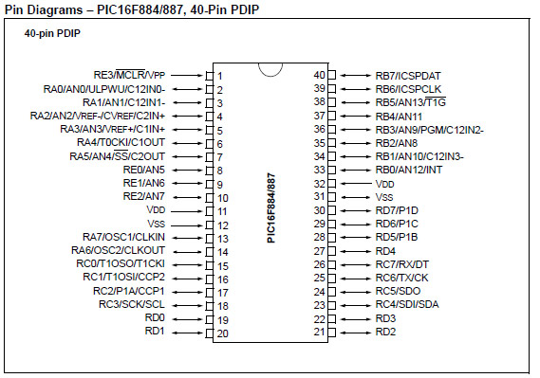

IN THIS PROJECT, I HAVE USED THE FOLLOWING COMPONENTS OF PIC 16F887….

**1. UART (UNIVERSAL ASYNCHRONOUS RECEIVER/TRANSMITTER)**

THIS SORT OF COMMUNICATION IS ASYNCHRONOUS, WHICH MEANS THAT A SPECIAL LINE FOR TRANSFERRING CLOCK SIGNAL IS NOT USED. IN SOME APPLICATIONS, SUCH AS RADIO CONNECTION OR INFRARED WAVES REMOTE CONTROL, THIS FEATURE IS CRUCIAL. SINCE ONLY ONE COMMUNICATION LINE IS USED, BOTH RECEIVER AND TRANSMITTER OPERATE AT THE SAME PREDEFINED RATE IN ORDER TO MAINTAIN NECESSARY SYNCHRONIZATION. THIS IS A VERY SIMPLE WAY OF TRANSFERRING DATA SINCE IT BASICALLY REPRESENTS THE CONVERSION OF 8-BIT DATA FROM PARALLEL TO SERIAL FORMAT. BAUD RATE IS NOT HIGH, UP TO 1 MBIT/SEC.

BASICALLY, I HAVE USED UART FOR WIFI MODULE. IN THIS, FIRST DATA IS TAKEN FROM ULTRASONIC SENSOR AND THEM COMPUTATION IS GO ON AND AFTER THAT IT IS UPLOAD OVER SERVER VIA **THINGSSPEAK WEBSITE** .

**2. TIMER**

TIMER CAN APLLIED IN 3 WAYS –TIMER0, TIMER1, TIMER2.TIMER0 AND TIMER1 CAN BE USED UPTO 8 BITS, BUT TIMER1 CAN BE USED UPTO 16 BITS SO I HAVE USED TIMER1.

TIMER IS BASICALLY A FEATURE OF PIC 16F887 IN WHICH IT USES OSCILATTOR TO GENERATE SOME FREQUENCY AND USING THIS FREQUENCY WE CAN COUNT THE TIME OF HOW MUCH OUR COMPONENT WAS ON FOR A PARTICULAR TIME.

SO, IN THIS PROJECT, I USED IT TO FOR HOW MUCH TIME THE ECHO OF ULTRASONIC SENSOR IS HIGH.

**3. INTERRUPT**

THE FIRST THING THE MICROCONTROLLER DOES WHEN AN INTERRUPT REQUEST ARRIVES IS TO EXECUTE THE CURRENT INSTRUCTION AND THEN STOPS THE REGULAR PROGRAM EXECUTION. AS A RESULT, THE CURRENT PROGRAM MEMORY ADDRESS IS AUTOMATICALLY PUSHED ONTO THE STACK AND THE DEFAULT ADDRESS (PREDEFINED BY THE MANUFACTURER) IS WRITTEN TO THE PROGRAM COUNTER. THE LOCATION FROM WHERE THE PROGRAM PROCEEDS WITH EXECUTION IS CALLED AN INTERRUPT VECTOR. FOR THE PIC16F887 MICROCONTROLLER, THIS ADDRESS IS 0004H.

A PART OF THE PROGRAM TO BE EXECUTED WHEN AN INTERRUPT REQUEST ARRIVES IS CALLED AN INTERRUPT ROUTINE. ITS FIRST INSTRUCTION IS LOCATED AT THE INTERRUPT VECTOR. HOW LONG WILL IT TAKE TO EXECUTE THIS SUBROUTINE AND WHAT IT WILL BE LIKE DEPENDS ON THE SKILLS OF THE PROGRAMMER AS WELL AS ON THE INTERRUPT SOURCE ITSELF. SOME OF THE MICROCONTROLLERS HAVE MORE INTERRUPT VECTORS (EVERY INTERRUPT REQUEST HAS ITS VECTOR), BUT IN THIS CASE THERE IS ONLY ONE. CONSEQUENTLY, THE FIRST PART OF THE INTERRUPT ROUTINE CONSISTS IN INTERRUPT SOURCE DETECTION.

FINALLY, WHEN THE INTERRUPT SOURCE IS RECOGNIZED AND THE INTERRUPT ROUTINE IS EXECUTED, THE MICROCONTROLLER REACHES THE **RETFIE** INSTRUCTION, POPS THE ADDRESS FROM THE STACK AND PROCEEDS WITH PROGRAM EXECUTION FROM WHERE IT LEFT OFF.

SO, IN THIS PROJECT I USED INTERRUPT AS , SUPPOSE THE CASE ARRIVED WHEN OBSTACLE IS AT INFINTE DISTANCE FROM ULTRASONIC SENSOR, THEN OUR CODE WILL GET STUCK AT A POSITION SO AFTER A CERTAIN DISTANCE , AN INTERRUPT WILL OCCUR , DISPLAYING ON LCD THAT THE OBJECT IS OUT OF RANGE.

**2. NUMERICAL LCD (LIQUID CRYSTAL DISPLAY)**

THE LCD IS A DOT MATRIX LIQUID CRYSTAL DISPLAY THAT DISPLAYS ALPHANUMERIC, KANA (JAPANESE) CHARACTER AND SYMBOLS. THE BUILT - IN CONTROLLER & DRIVER LSIS PROVIDE CONVENIENT CONNECTIVELY BETWEEN A DOT MATRIX LCD AND MOST 4 OR 8 BIT MICROPROCESSORS OR MICROCONTROLLERS. ALL THE FUNCTIONS REQUIRED FOR DOT MATRIX LIQUID CRYSTAL DISPLAY DRIVE ARE INTERNALLY PROVIDED. INTERNAL REFRESH IS PROVIDED BY THE LCD. THE CMOS TECHNOLOGY MAKES THE DEVICE IDEAL FOR APPLICATION IN HAND HELD, PORTABLE AND OTHER BATTERY POWERED INSTRUMENTS WITH LOW POWER CONSUMPTION.

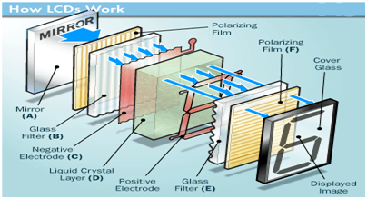

**LCD LAYERED DIAGRAM**

THE PRINCIPLE BEHIND THE LCD’S IS THAT WHEN AN ELECTRICAL CURRENT IS APPLIED TO THE LIQUID CRYSTAL MOLECULE, THE MOLECULE TENDS TO UNTWIST. THESE CAUSES THE ANGLE OF LIGHT WHICH IS PASSING THROUGH THE MOLECULE OF THE POLARIZED GLASS AND ALSO CAUSE A CHANGE IN THE ANGLE OF THE TOP POLARIZING FILTER. AS A RESULT A LITTLE LIGHT IS ALLOWED TO PASS THE POLARIZED GLASS THROUGH A PARTICULAR AREA OF THE LCD. THUS THAT PARTICULAR AREA WILL BECOME DARK COMPARED TO OTHER.

LCD COMMAND USED:

**0X38-**TO INITIALIE LCD DRIVER UNIT.

**0X01-**TO CLEAR LCD.

**0X80-**BEGINNING LOCATION OF FIRST ROW.

**0XC0-** BEGINNING LOCATION OF SECOND ROW.

**3. ULTRASONIC SENSOR**

ULTRASONIC RANGING MODULE HC - SR04 PROVIDES 2CM - 400CM NON-CONTACT MEASUREMENT FUNCTION, THE RANGING ACCURACY CAN REACH TO 3MM. THE MODULES INCLUDES ULTRASONIC TRANSMITTERS, RECEIVER AND CONTROL CIRCUIT. THE BASIC PRINCIPLE OF WORK: (1) USING IO TRIGGER FOR AT LEAST 10US HIGH LEVEL SIGNAL, (2) THE MODULE AUTOMATICALLY SENDS EIGHT 40 KHZ AND DETECT WHETHER THERE IS A PULSE SIGNAL BACK. (3) IF THE SIGNAL BACK, THROUGH HIGH LEVEL, TIME OF HIGH OUTPUT IO DURATION IS THE TIME FROM SENDING ULTRASONIC TO RETURNING. TEST DISTANCE = (HIGH LEVEL TIME×VELOCITY OF SOUND (340M/S) / 2.

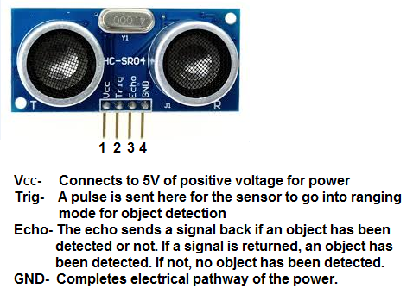

**4. ESP8266 (WIFI MODULE)**

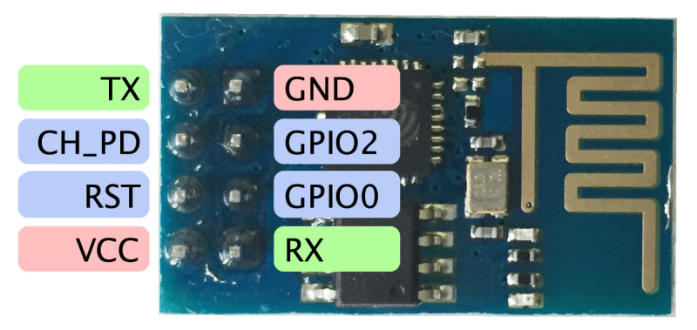

ESP8266 IS THE NAME OF THE MICROCONTROLLER DEVELOPED BY ESPRESSIF SYSTEMS WHICH IS A COMPANY BASED OUT OF SHANGHAI. THIS MICROCONTROLLER HAS THE ABILITY TO PERFORM WIFI RELATED ACTIVITIES HENCE **IT IS WIDELY USED AS A WIFI MODULE**.

THERE ARE MANY TYPES OF ESP8266 MODULE AVAILABLE RANGING FROM ESP8266-01 TO ESP8266-12. THE ONE THAT I AM GOING TO USE IN MY PROJECT IS THE ESP8266-01 BECAUSE IT THE CHEAPEST ONE AND EASILY AVAILABLE. HOWEVER ALL THE ESP MODULES HAVE ONLY ONE TYPE OF ESP PROCESSOR, WHAT DIFFERS IS ONLY THE TYPE OF BREAKOUT BARD USED. THE BREAKOUT BOARD OF ESP8266-01 WILL HAVE ONLY 2 GPIO PINS WHEREAS IN OTHER BOARDS IT WILL BE HIGHER.

**SPECIFICATIONS OF WIFI MODULE**

|  |  |
| --- | --- |
| Voltage | 3.3V |
| Current Consumption | 10uA-170mA |
| Maximum current consumption during flashing | 800mA |
| Flash Memory | 16MB (512K normal) |
| Processor | Ten silica L106 32 bit |
| Processor Speed | 80-160MHz |
| RAM | 32K+80K |
| GPIO | 17 (but most are multiplexed) |
| Analog to digital Converter | 1 (10-bit) |
| Maximum TCP connections | 5 |

HERE, I USED TO CONNECT TO THE INTERNET AND TRANSFER THE DATA THAT HAS BEEN RETREIVED FROM ULTRASONIC SENSOR OVER THE SERVER OF THINGS SPEAK WEBSITE.

**5. IC 7805**

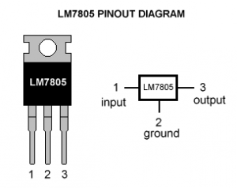

IC 7085 IS USED AS A VOLTAGE REGULATING COMPONENT IN THE WHOLE CIRCUIT. WITH THE HELP OF THIS, WE CAN GET A CONSTANT OUTPUT VOLTAGE OF 5V IRRESPECTIVE OF THE INPUT VOLTAGE. HERE, I USED IT POWER UP MY PIC MICRO CONTROLLER AS WELL AS LCD DISPLAY.

IT WORKS AS WHEN THE HIGH VOLTAGE IS APPLIED ACROSS THE IC 7805, IT DRAINED THE EXCESS VOLTAGE IN TERM OF HEAT AND THEREFORE IT IS ALSO KNOWN AS HEAT SINK.

IT IS MOST USEFUL CONPONENT IN MOST OF THE CIRCUIT WHERE CONST 5V VOLATAGE IS REQUIERED.

HERE ARE RATINGS….

Input voltage range 7V- 35V

Current rating IC =1A

Output voltage range   VMax=5.2V ,,VMin=4.8V

**6. LD1117**

THIS IS THE BASIC LD1117V33 VOLTAGE REGULATOR, A LOW DROP POSITIVE REGULATOR WITH A 3.3V FIXED OUTPUT VOLTAGE. THIS FIXED REGULATOR PROVIDES A GREAT AMOUNT OF STABILITY AND PROTECTION FOR YOUR PROJECT AND WITH ITS ON SHIP TRIMMING THIS REGULATOR IS ABLE TO REACH AN OUTPUT VOLTAGE TOLERANCE WITHIN ±1%. EACH ONE OF THESE VOLTAGE REGULATORS CAN OUTPUT A MAX CURRENT OF 800MA.

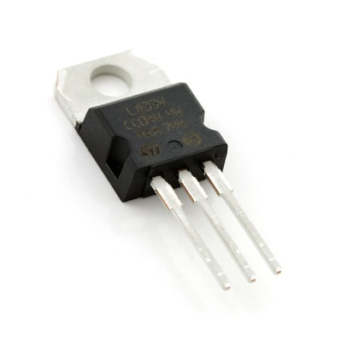

HERE, I USED LD1117 FOR ESP8266 MODULE AS THIS MODULE ONLY WORKS AT MAXIMUM VOLTAGE OF 3.3V AND REQUIRE A CURRENT MINIMUM 300A.

IN MY PROJECT, I HAVE USED SEPARATE SUPPLY FOR ESP8266 MODULE AND PIC MICRO CONTOLLER BECAUSE THE REQUIRED VOLTAGE FOR THE BOTH THE IS DIIFERENT, EVEN THOUGH I HAVE USED DIFFERENT VOLATGE REGULATORS FOR BOTH THEM, IT IS EASY WHEN WE SUPPLY VOLTAGES WITH DIFFERENT POWWER SUPPLY.

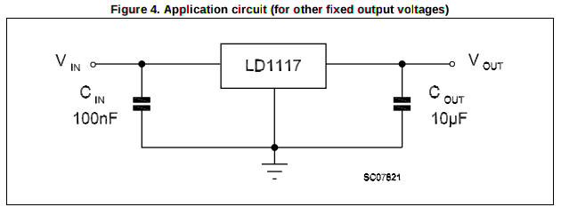

**WORKING FLOW CHART**

ULTRASONICS SENSOR MEASURES THE HEIGHT OF THE EMPTY DUSTBIN

WHEN THE DUSTBIN GETS FULL, LED WILL BLINK ALONG WITH THE BEEP IN THE BUZZER, ALONG WITH THE DISPLAY IN LCD

LCD DISPLAY SHOW THE CURRENT STATUS OF THE DUSTBIN

LCD WILL DISPLAY-CONNECTED TO INTERNET

ON CONNECTING TO INTERNET, IT WILL BLINK THE LIGHT.

WAIT FOR ESP MODULE TO GET CONNECTED TO INTRENET.

ESP MODULE SHOULD BLINK THE LED.

PIC AND ESP MODULE GETS CONNECTED TO POWER SUPPLY

**APPLICATIONS**

1. IT IS USED TO MONITOR THE GARBAGE OVER THE INTERNET.
2. IT CAN USED TO MONITOR WATER LEVEL OF A DAM OVER THE INTERNET WITH INDICATION SYSTEM WITH IT.
3. IT CAN BE USED TO DETECT HEIGHT OF THE BUIDLDING.

**FUTURE IMPROVEMENTS**

1. IN PLACE OF ADAPTER, WE CAN USE SOLAR PANEL, TO POWER THE PIC MICRO CONTROLLER AS WELL AS ESP MODULE.

2. WE CAN USE TRANSMITTER AND RECIEVER TO CONNECT TO ULTRASONIC SENSOR AND PIC MCU, AS IT WILL LEAD TO WIRELESS COMMUNICATION BETWEEN AND IT WILL BE EASY TO USE MORE ULTRASONIC SENSOR WITH PIC MCU.